Final Exam JV
Location: Del Val HS
Date: Sunday 1/31/2016
70

South Plainfield
Randolph
East Brunswick
East Brunswick
Washington
Win by Forfeit
BYE
BYE
South Plainfield
East Brunswick
East Brunswick
Washington
Madden Obado
George Marakis
Shawn Redfield
Evan Schimanski
2
3
4
7
8
12
8-2
Washington
Pin at 3:0
East Brunswick
Madden Obado
Pin at 2:00
Washington
Shawn Redfield
Evan Schimanski
Devan Sawyer
George Marakis
Bye
Bye
Madden Obado
Bye
Shawn Redfield
55
141
142
253
SECOND PLACE
Washington
FIRST PLACE
Shawn Redfield
Shawn Redfield

6
10
11
South Plainfield
7
L
L3
L4
BYE
South Plainfield
Pin at 3:03
South Plainfield
East Brunswick
Win by Inj Def
East Brunswick
THIRD PLACE
FOURTH PLACE
Randolph
BYE
Randolph
5
9
East Brunswick
8
L
L1
L2
BYE
BYE
BYE
Evan Schimanski
Evan Schimanski
Evan Schimanski
BYE
Devan Sawyer
Devan Sawyer
George Marakis
170
188
Evan Schimanski
South Plainfield
L-55
L-142
L-141
George Marakis
George Marakis

75

Hillsborough
Phillipsburg
Randolph
Edison
BYE
BYE
BYE
Hillsborough
Randolph
Phillipsburg
Edison
Alex Silva
Gavin Hawk
Ryan Eagle
Nicolas Donoven
2
3
4
7
8
12
2-0
Phillipsburg
4-0
Randolph
Alex Silva
Pin at 0:50
Phillipsburg
Gavin Hawk
L1
BYE
Nicolas Donoven
Bye
Gavin Hawk
Bye
Bye
Alex Silva
Bye
Ryan Eagle
143
144
254
Randolph
SECOND PLACE
Alex Silva
Phillipsburg
FIRST PLACE
Gavin Hawk
Gavin Hawk

6
10
11
Hillsborough
7
L
L3
L4
BYE
Hillsborough
4-3
Edison
Hillsborough
BYE
Edison
THIRD PLACE
FOURTH PLACE
5
9
Edison
L
8
L2
BYE
BYE
BYE
Nicolas Donoven
Nicolas Donoven
Ryan Eagle
BYE
BYE
Ryan Eagle
189
Ryan Eagle
Edison
L-144
L-143
Nicolas Donoven
Ryan Eagle

80

Watchung Hills
Washington
East Brunswick
Ridge
Woodbridge
North Hunterdon
Washington
Pin at 1:03
Pin at 1:30
Pin at 2:45
Watchung Hills
Woodbridge
East Brunswick
Washington
Nico Diaz
Preston Harduby
Noah Dinapoli
Connor Kim
2
3
4
7
8
12
4-2
Washington
6-5
Watchung Hills
Connor Kim
4-2
Washington
Noah Dinapoli
Connor Kim
Walker Heller
Preston Harduby
Andrew Mahdavian
Bye
Nico Diaz
Sean Hyland
Noah Dinapoli
56
57
58
145
146
255
SECOND PLACE
Washington
FIRST PLACE
Noah Dinapoli
Noah Dinapoli

North Hunterdon
Ridge
Pin at 0:24
Ridge
6
10
11
Woodbridge
L
7
L3
L4
9-3
Woodbridge
4-2
Woodbridge
East Brunswick
6-0
East Brunswick
THIRD PLACE
FOURTH PLACE
Washington
BYE
Washington
5
9
East Brunswick
8
L
L1
L2
Sean Hyland
Andrew Mahdavian
Andrew Mahdavian
Nico Diaz
Nico Diaz
Nico Diaz
BYE
Walker Heller
Walker Heller
Preston Harduby
83
171
172
190
Nico Diaz
Woodbridge
L-56
L-57
L-58
L-146
L-145
Preston Harduby
Preston Harduby

85 No Weight Class This Tournament
90

North Warren
Ridge
Del Val
Woodbridge
Washington
Pin at 1:36
BYE
BYE
North Warren
Ridge
Del Val
Washington
Jake Fern
Stephen Em
Stephen Malia
Collin Vorhees
2
3
4
7
8
12
6-2
Ridge
Pin at 1:20
Ridge
Jake Fern
Pin at 3:00
Washington
Stephen Malia
Collin Vorhees
Jake Fern
Stephen Em
Bye
Bye
Liam McCabe
Bye
Stephen Malia
59
147
148
256
SECOND PLACE
Ridge
FIRST PLACE
Jake Fern
Jake Fern

6
10
11
North Warren
7
L
L3
L4
BYE
North Warren
8-1
Del Val
North Warren
Pin at 1:39
Del Val
THIRD PLACE
FOURTH PLACE
Woodbridge
BYE
Woodbridge
5
9
Del Val
8
L
L1
L2
BYE
BYE
BYE
Collin Vorhees
Collin Vorhees
Stephen Em
BYE
Liam McCabe
Liam McCabe
Stephen Em
173
191
Stephen Em
Del Val
L-59
L-148
L-147
Collin Vorhees
Stephen Em

95

North Hunterdon
Phillipsburg
Watchung Hills
Del Val
Phillipsburg
Hillsborough
Pin at 3:0
3-0
BYE
North Hunterdon
Phillipsburg
Phillipsburg
Hillsborough
Jay Paliitto
Tanner Moore
Daniel Guerrero
Parker Brennan
2
3
4
7
8
12
Major Dec. 10-0
Phillipsburg
Pin at 3:25
Phillipsburg
Jay Paliitto
Win by Inj Def
Hillsborough
Daniel Guerrero
Parker Brennan
Jay Paliitto
Elhanan Wilson
Bye
Bye
Andrew Larsen
Tanner Moore
Daniel Guerrero
60
61
149
150
257
SECOND PLACE
Phillipsburg
FIRST PLACE
Jay Paliitto
Jay Paliitto

Watchung Hills
BYE
Watchung Hills
6
10
11
North Hunterdon
L
7
L3
L4
7-2
North Hunterdon
Pin at 4:24
North Hunterdon
Del Val
Win by Forfeit
Del Val
THIRD PLACE
FOURTH PLACE
Del Val
BYE
Del Val
5
9
Phillipsburg
8
L
L1
L2
Elhanan Wilson
BYE
Elhanan Wilson
Parker Brennan
Parker Brennan
Parker Brennan
BYE
Andrew Larsen
Andrew Larsen
Tanner Moore
174
175
192
Parker Brennan
North Hunterdon
L-60
L-61
L-150
L-149
Andrew Larsen
Andrew Larsen

100
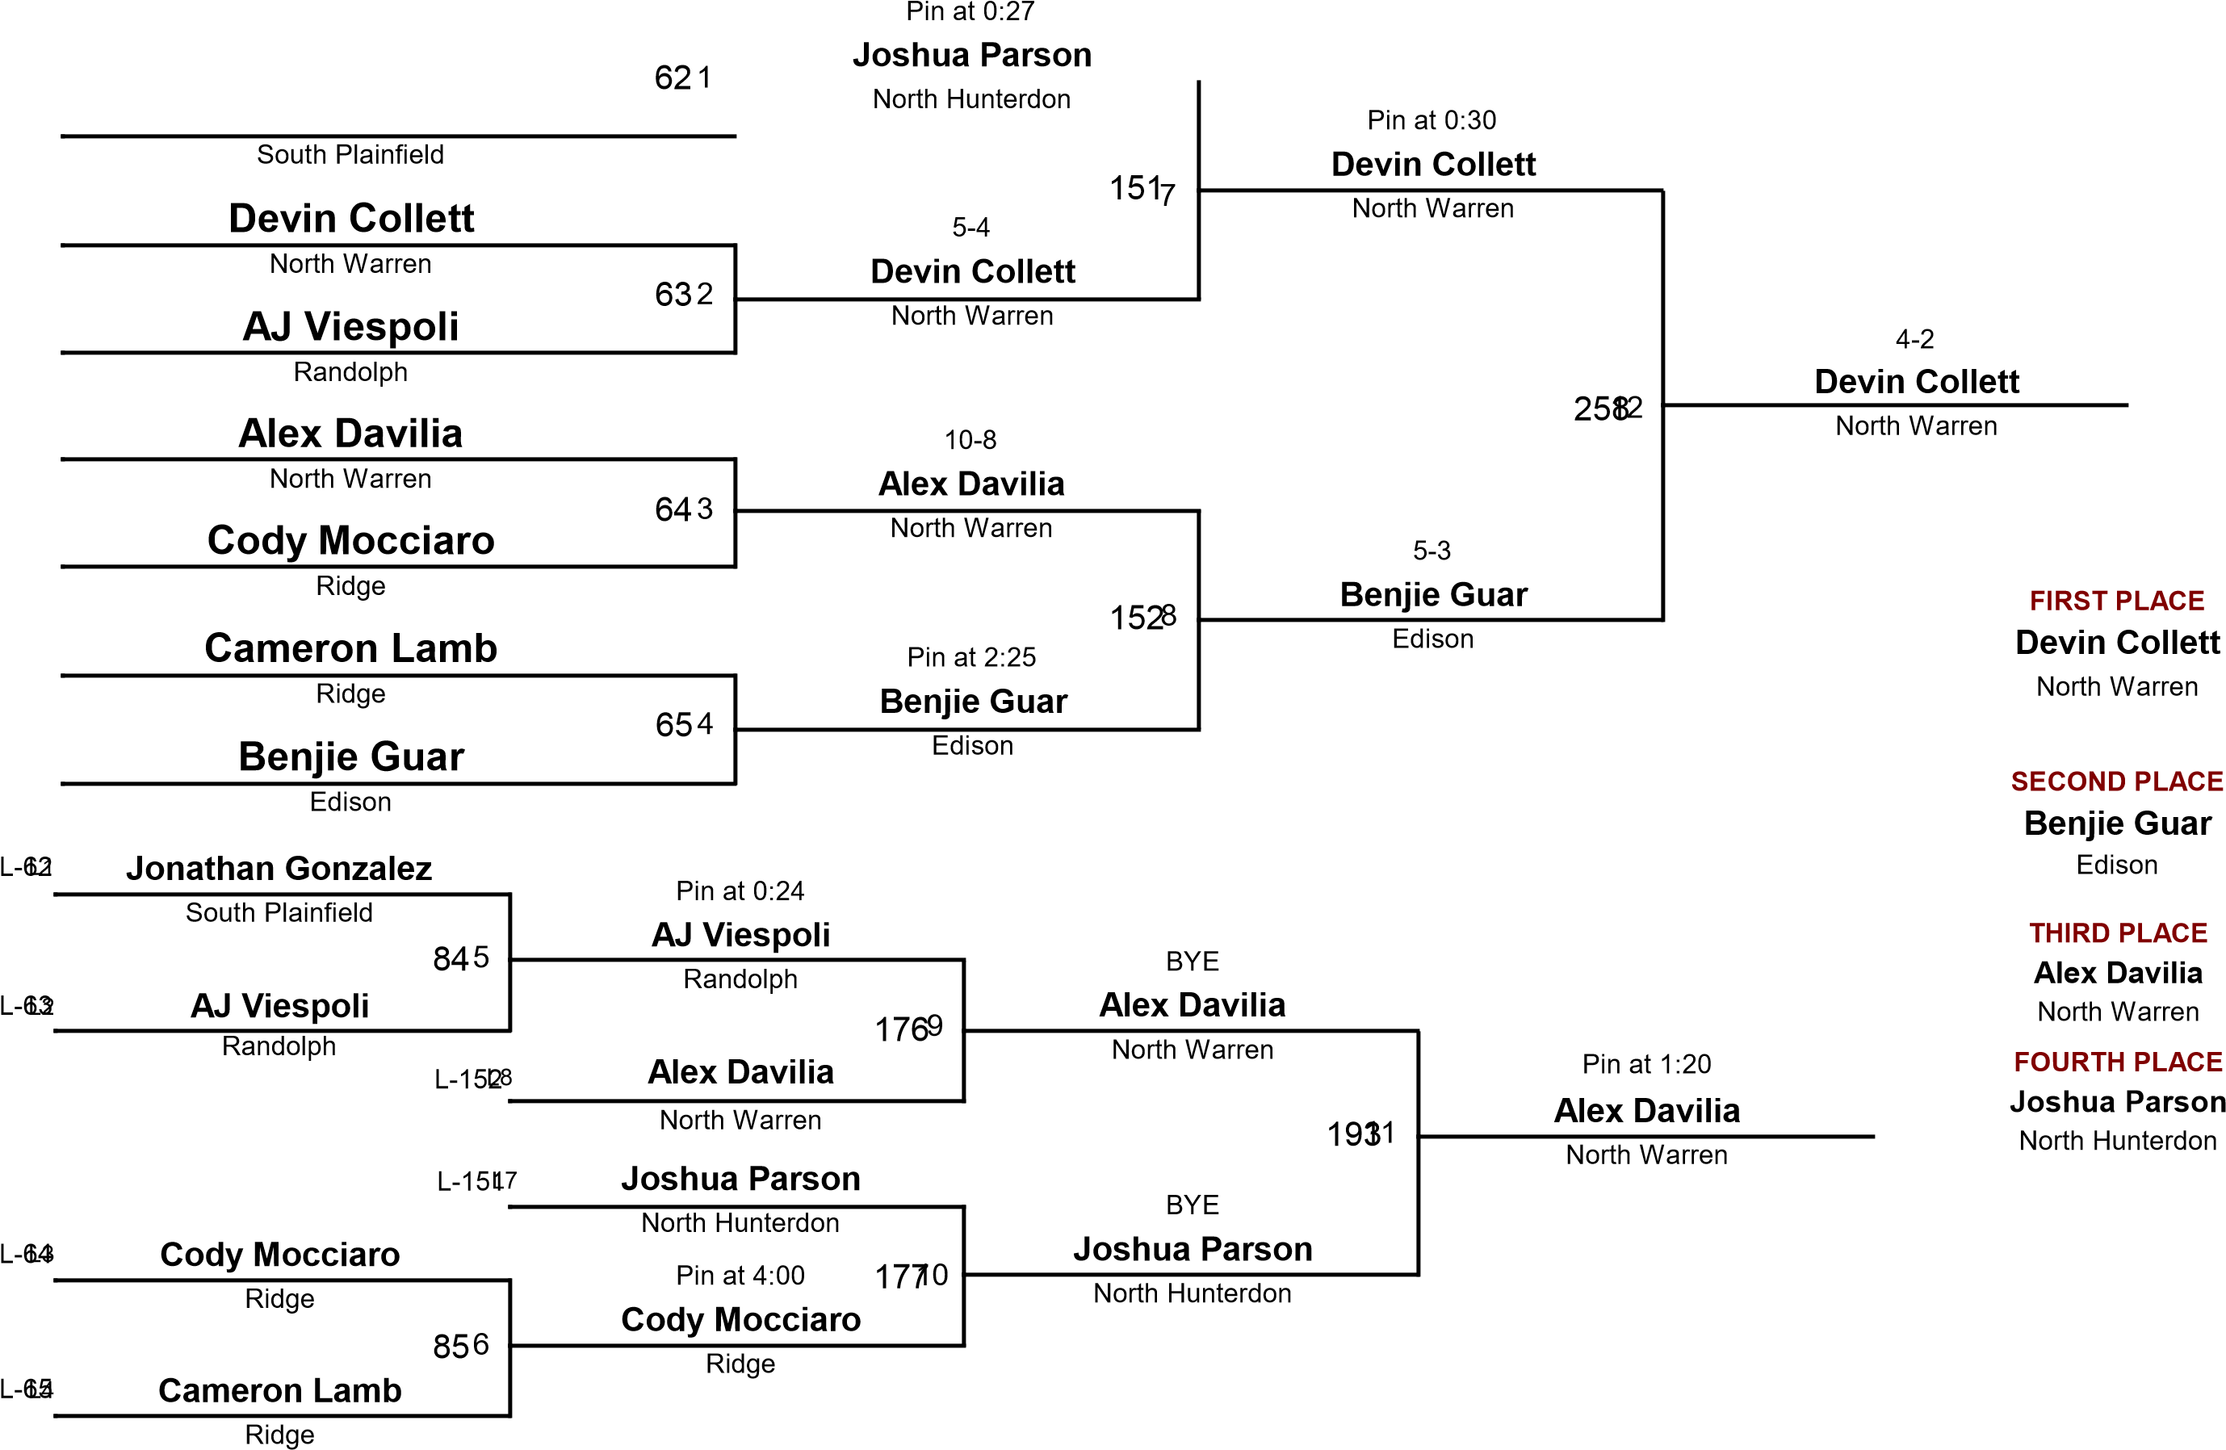
Jonathan Gonzalez

106

Edison
Phillipsburg
Hillsborough
South Plainfield
Washington
BYE
7-1
Pin at 0:30
BYE
Edison
South Plainfield
Hillsborough
Ridge
Mike Kurilew
Ryan Oram
Ryan Duguay
Javian Medina
1
2
3
4
7
8
12
Pin at 0:22
Hillsborough
Pin at 1:09
South Plainfield
Mike Kurilew
Pin at 1:00
Hillsborough
Ryan Oram
Javian Medina
Steven Kantenwein
Ryan Oram
Bye
Bye
Mike Kurilew
Owen Frizzell
Ryan Duguay
66
67
153
154
259
SECOND PLACE
Hillsborough
FIRST PLACE
Ryan Oram
Ryan Oram

Washington
BYE
Washington
6
10
11
Edison
7
L
L3
L4
Pin at 2:52
Washington
Pin at 1:48
Ridge
Washington
Tech Fall 18-2
Ridge
THIRD PLACE
FOURTH PLACE
Phillipsburg
Phillipsburg
5
9
Ridge
L
8
L1
L2
Owen Frizzell
BYE
Owen Frizzell
Javian Medina
Owen Frizzell
Ryan Duguay
Steven Kantenwein
Steven Kantenwein
Ryan Duguay
178
179
194
Ryan Duguay
Ridge
L-66
L-67
L-154
L-153
Owen Frizzell
Ryan Duguay
112
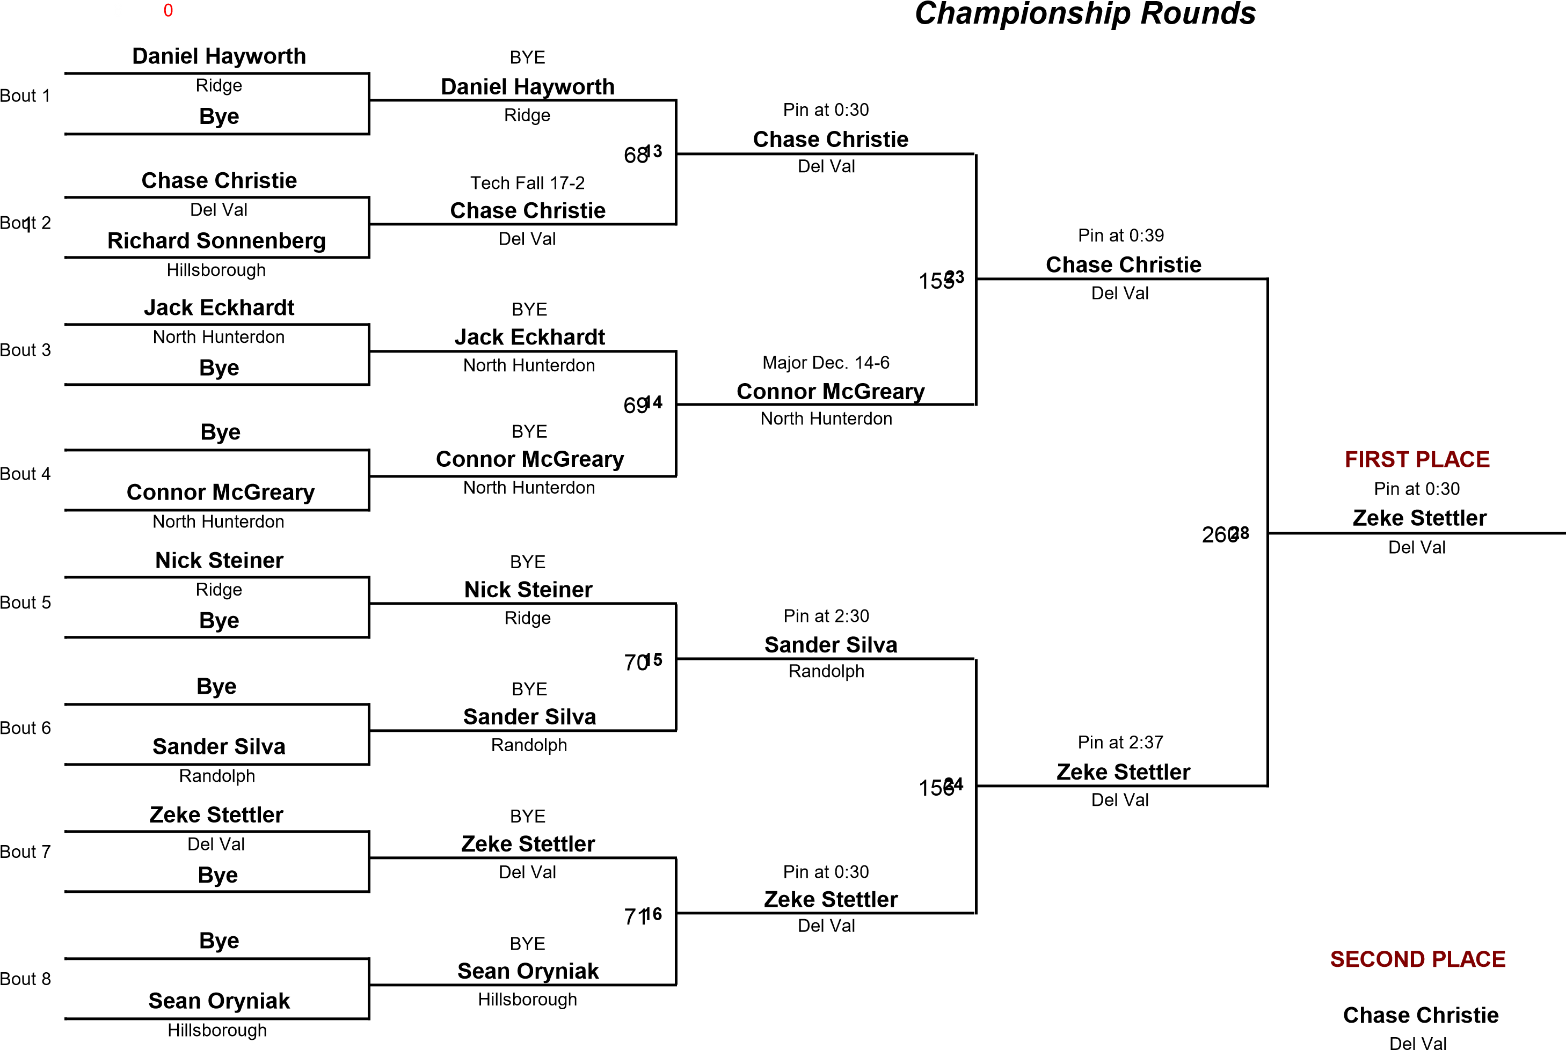
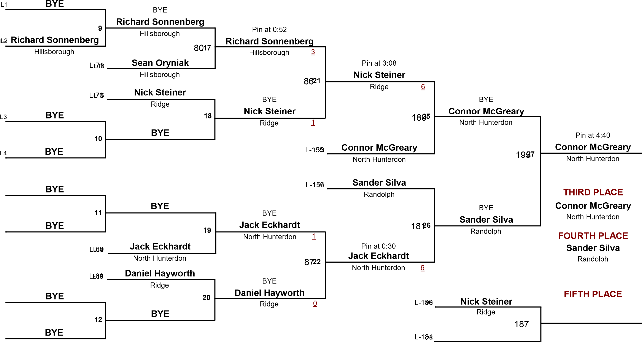

118

Del Val
North Hunterdon
North Warren
Phillipsburg
Hillsborough
Pin at 0:30
BYE
BYE
Del Val
North Hunterdon
North Warren
Hillsborough
Evan Leopold
Austin Collett
Christian Kruskall
Ben Kirkpatrick
1
2
3
4
7
8
12
Pin at 3:00
North Warren
Pin at 2:18
North Hunterdon
Evan Leopold
Pin at 2:11
North Warren
Austin Collett
Ben Kirkpatrick
Evan Leopold
Austin Collett
Bye
Bye
Nazir Jimenez
Bye
Christian Kruskall
72
157
158
261
SECOND PLACE
North Warren
FIRST PLACE
Austin Collett
Austin Collett

6
10
11
Del Val
L
7
L3
L4
BYE
Del Val
Pin at 0:30
Hillsborough
Del Val
Pin at 0:49
Hillsborough
THIRD PLACE
FOURTH PLACE
Phillipsburg
BYE
Phillipsburg
5
9
Hillsborough
8
L
L1
L2
BYE
BYE
BYE
Ben Kirkpatrick
Ben Kirkpatrick
Christian Kruskall
BYE
Nazir Jimenez
Nazir Jimenez
Christian Kruskall
182
196
Christian Kruskall
Hillsborough
L-72
L-158
L-157
Ben Kirkpatrick
Christian Kruskall

126
 | 3-PERSON ROUND ROBIN
Robert Fletcher | Pin at 0:30 |  | 2
North Warren  Sean Reed |  | Robert Fletcher
 |  | North Warren  2-0  Nicholas Agugliaro | 0

ROUND 1 731
FIRST PLACE

Robert Fletcher North Warren

SECOND
Nicholas Agugliaro Watchung Hills
THIRD PLACE

Sean Reed North Hunterdon

130

Hillsborough
South Plainfield
Phillipsburg
North Warren
Pin at 1:20
BYE
BYE
North Warren
Phillipsburg
Edison
Jack Swistak
Noah Garriuques
Elijah St. Phard
Deb Varun
1
2
3
4
7
8
12
7-0
Edison
7-4
Hillsborough
Deb Varun
9-3
Edison
Elijah St. Phard
Deb Varun
Kenney Clevenger
Noah Garriuques
Bye
Bye
Jack Swistak
Bye
Elijah St. Phard
74
160
161
263

Edison
FIRST PLACE
Elijah St. Phard
Elijah St. Phard

6
10
11
North Warren
L
7
L3
L4
BYE
North Warren
Major Dec. 12-3
Phillipsburg
North Warren
Pin at 0:53
Phillipsburg
THIRD PLACE
FOURTH PLACE
South Plainfield
South Plainfield
5
9
Phillipsburg
8
L
L1
L2
BYE
BYE
BYE
Jack Swistak
Jack Swistak
Noah Garriuques
Kenney Clevenger
Kenney Clevenger
Noah Garriuques
183
197
Noah Garriuques
Phillipsburg
L-74
L-161
L-160
Jack Swistak
Noah Garriuques
140

 | 3-PERSON ROUND ROBIN
Frankie Gomes | 13-11 |  | 0
Watchung Hills  Matt Newman |  | Matt Newman
 |  | Ridge  5-3  Matt Newman | 0
Ridge
Nick Almonte
Edison
Matt Newman
 |  | Ridge  7-5  Frankie Gomes | 0
Ridge
Nick Almonte
Edison
Frankie Gomes
 |  | Watchung Hills
ROUND 1 751
FIRST PLACE
Matt Newman

SECOND PLACE Frankie Gomes
ROUND 2 1622
THIRD PLACE

Nick Almonte
ROUND 3 2643
Watchung Hills

150

North Warren
Edison
Randolph
North Hunterdon
Pin at 1:21
BYE
BYE
North Hunterdon
Randolph
South Plainfield
Andrew Franklin
Kristopher Charles
Myles Cheatham
Dylan Lobycz
1
2
3
4
7
8
12
Pin at 3:15
North Hunterdon
Pin at 1:00
North Hunterdon
Andrew Franklin
Pin at 3:10
Randolph
Kristopher Charles
Dylan Lobycz
Jaydran Tehada
Kristopher Charles
Bye
Bye
Andrew Franklin
Bye
Myles Cheatham
76
163
164
265
SECOND PLACE
North Hunterdon
FIRST PLACE
Andrew Franklin
Andrew Franklin

6
10
11
North Warren
L
7
L3
L4
BYE
North Warren
Pin at 0:30
North Warren
South Plainfield
Pin at 4:21
South Plainfield
THIRD PLACE
FOURTH PLACE
Edison
Edison
5
9
South Plainfield
8
L
L1
L2
BYE
BYE
BYE
Dylan Lobycz
Dylan Lobycz
Dylan Lobycz
Jaydran Tehada
Jaydran Tehada
Myles Cheatham
184
198
Dylan Lobycz
North Warren
L-76
L-164
L-163
Myles Cheatham
Myles Cheatham

175

Randolph
Ridge
Ridge
North Hunterdon
South Plainfield
BYE
Pin at 0:29
Pin at 1:20
BYE
Randolph
Ridge
South Plainfield
South Plainfield
Collin Scherzer
Gabe Mont
Lawrence Castro
Nick Madalian
1
2
3
4
7
8
12
Pin at 1:00
Randolph
Pin at 1:23
Randolph
Nick Madalian
Pin at 0:45
South Plainfield
Gabe Mont
Nick Madalian
Collin Scherzer
Mike Duncan
Bye
Bye
Michael Lenert
Gabe Mont
Lawrence Castro
77
78
165
166
266
SECOND PLACE
Randolph
FIRST PLACE
Nick Madalian
Nick Madalian

Ridge
BYE
Ridge
6
10
11
Ridge
7
L
L3
L4
Pin at 0:22
Ridge
Pin at 0:30
Ridge
North Hunterdon
8-7
North Hunterdon
THIRD PLACE
FOURTH PLACE
North Hunterdon
North Hunterdon
5
9
South Plainfield
8
L
L1
L2
Mike Duncan
BYE
Mike Duncan
Collin Scherzer
Collin Scherzer
Collin Scherzer
Michael Lenert
Michael Lenert
Lawrence Castro
185
186
199
Collin Scherzer
Ridge
L-77
L-78
L-166
L-165
Michael Lenert
Michael Lenert
HWT

 | 3-PERSON ROUND ROBIN
Aryan Patel | Pin at 4:33 |  | 2
Washington  Ryan Stewart |  | Aryan Patel
 |  | Washington  Pin at 1:14  Jovanni Mendez | 2
Phillipsburg
Jovanni Mendez
South Plainfield
Ryan Stewart
 |  | South Plainfield  Pin at 2:00  Jovanni Mendez | 2
Phillipsburg
Jovanni Mendez
South Plainfield
Aryan Patel
 |  | South Plainfield

ROUND 1 791
FIRST PLACE

Jovanni Mendez
SECOND PLACE Aryan Patel
ROUND 2 1672
THIRD PLACE

Ryan Stewart
ROUND 3 2673
Washington

