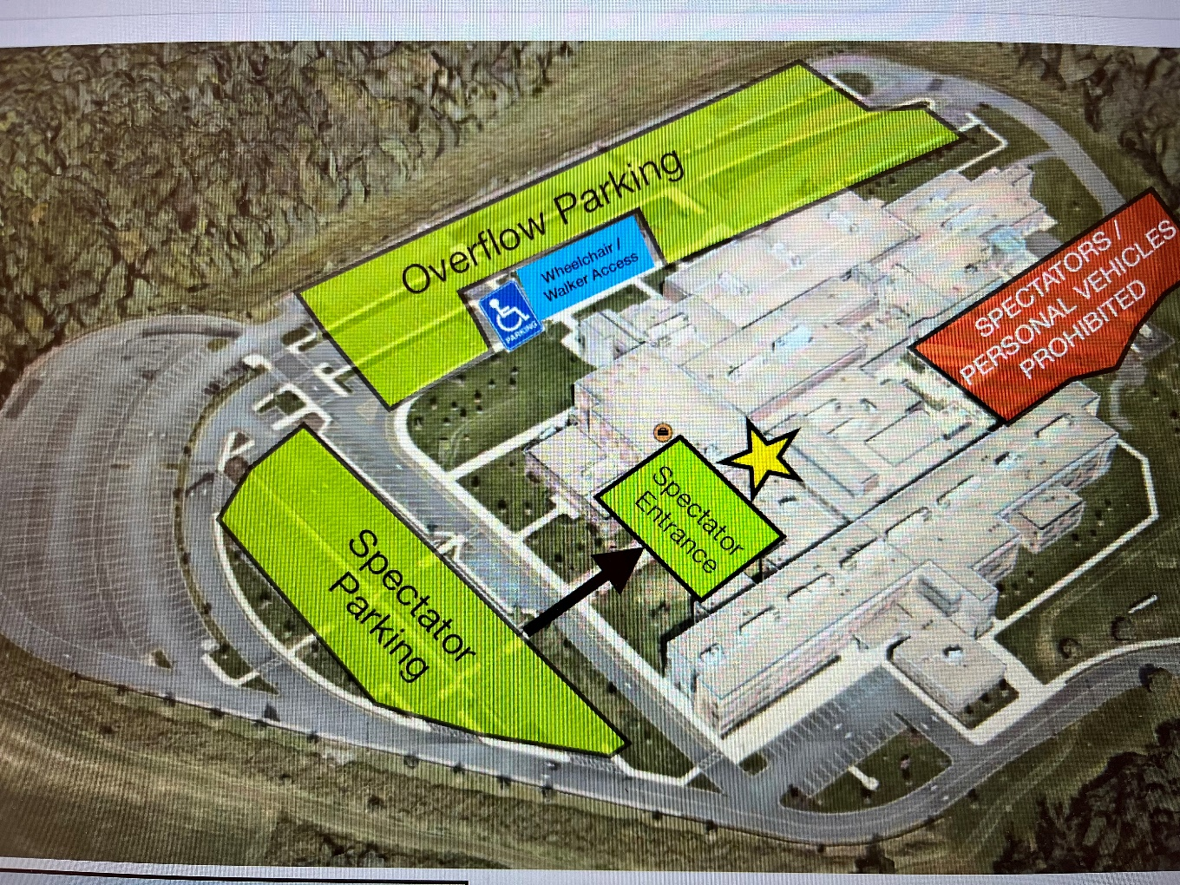
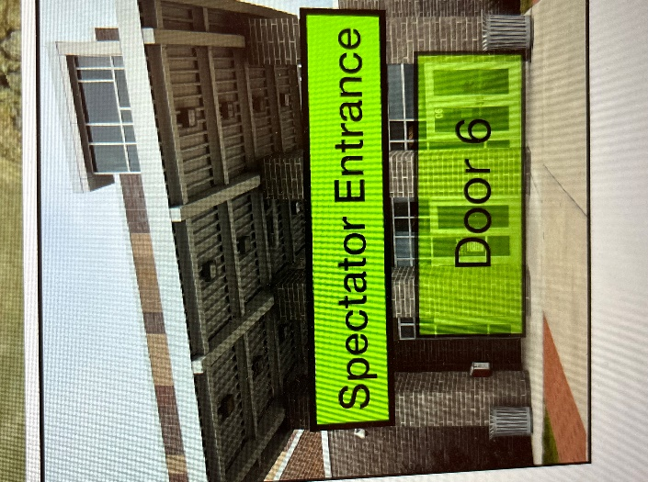
NO FOOD OR DRINK IS PERMITTED IN THE PHS GYM

